Nama : Fachreza Norrahma

NIM : 19051397036

Prodi : D4 Managemen Informatika A

TUGAS STRUKTUR DATA TREE AND BINARY TREE

**LATIHAN 1**

1. Buat Diagram Venn, notasi kurung dan notasi tingkat !

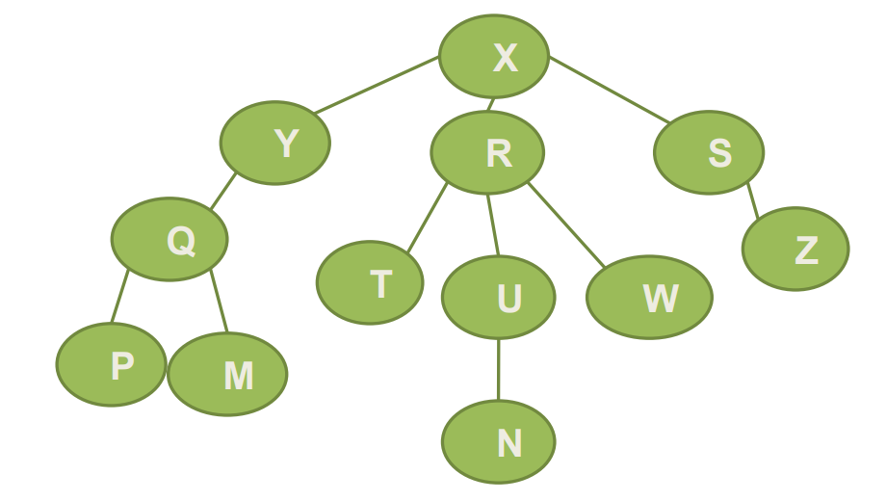

1. Identifikasikan!

Ancestor (N) =

Descendant (Y) =

Parent (Z) =

Child (Q) =

Sibling (U) =

Size =

Height =

Root =

leaf =

Degree (R)

**JAWAB :**

1. Diagram Venn

M

P

Q

N

W

U

T

Z

y

R

S

x

Notasi Kurung

(X(Y(Q(P,M)),(R(T,W,U(N)),(S(Z))

Notasi Tingkat

Z

S

W

N

M

P

T

U

R

Q

Y

X

1. Ancestor (N) = U,R,X

Descendant (Y) = Q,P,M

Parent (Z) = S

Child (Q) = P,M

Sibling (U) = T,W

Size = 12

Height = 4

Root = X

leaf = P,M,N,Z

Degree (R)

LATIHAN 2

Gambarkan Pohon Biner dengan ketentuan sbb :

Ancestor (M) = Z, X

Descendant (Y) = K, L

Parent (N) = Z

Child (Z) = M, N

Sibling (Y) = Z

Size = 7

Height = 3

Root = X

Leaf = K, L, M, N

**JAWAB :**

Z

N

M

L

K

Y

X

LATIHAN 3

Telusuri pohon biner berikut dengan menggunakan metode pre, in, post !

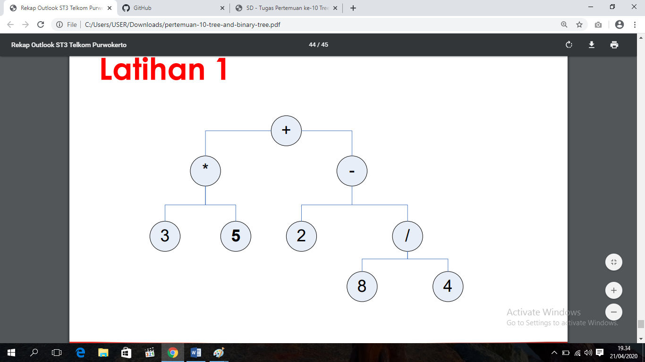

**JAWAB :**

* Preorder of Expression Tree

+ * 3 5 – 2 / 8 4 •

* Inorder of Expression Tree

3 * 5 + 2 8 / 4 2 - •

* Postorder of Expression Tree

3 5 * 8 4 / 2 - +

LATIHAN 4

Telusuri pohon biner berikut dengan menggunakan metode pre, in, post !

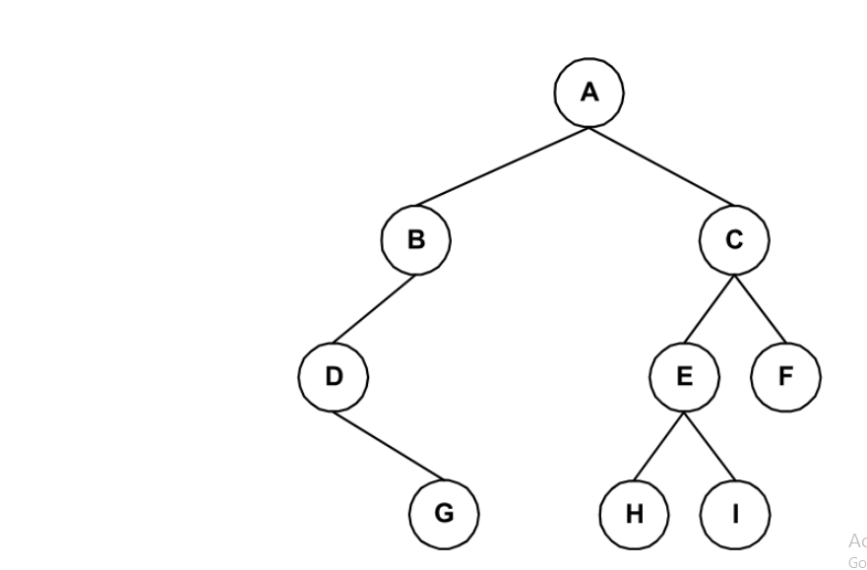

**JAWAB :**

* Preorder of Expression Tree

A B D G C E H I F

* Inorder of Expression Tree

D G B A H E I C F

* Postorder of Expression Tree

G D B H I E F C A

LATIHAN 5

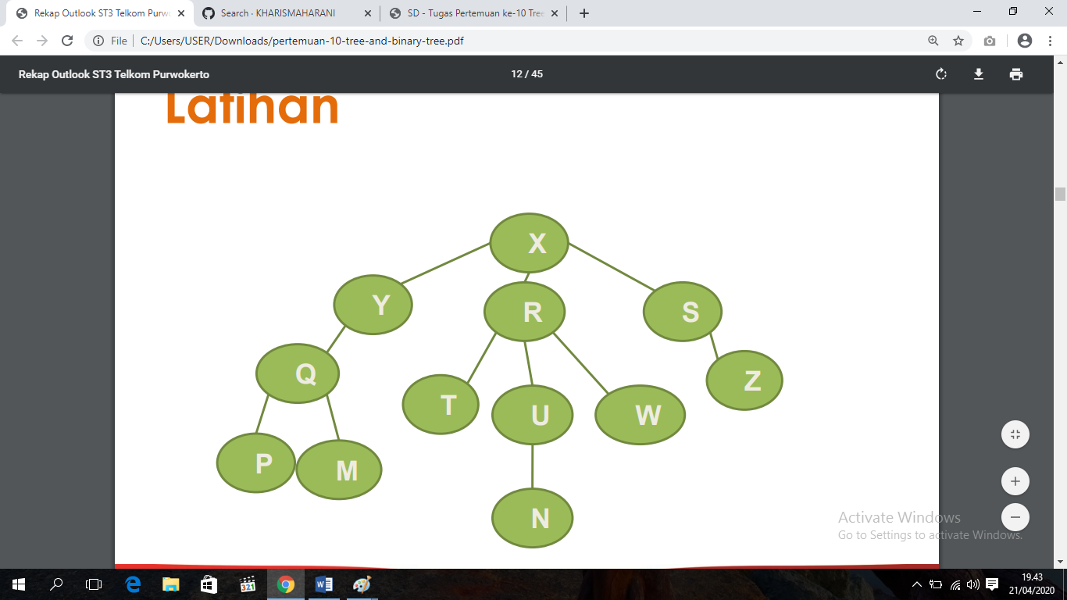

**JAWAB :**

Anchestor = S, X

Descendants = Z

Parent = Y, R, U

Child = Y, R, S, Q, U

ibling = T, W

Size = 12

Height = 4

Root = X

Leaf = P, M, N, Z

Degree = tidak ada